Interfacing Seven Segment Display to 8051 Development kit


LAB # 05

Spring 2024
CSE-307L Microprocessor Based System Design Lab

Submitted by: Ali Asghar
Registration No.: 21PWCSE2059
Class Section: C

“On my honor, as student of University of Engineering and Technology, I have neither given nor received unauthorized assistance on this academic work.”

Submitted to:
Dr. Asif Ali Khan

Date:
29th March 2024

Department of Computer Systems Engineering
University of Engineering and Technology, Peshawar

Task 1:
Run all the programs given in the lecture

Code:
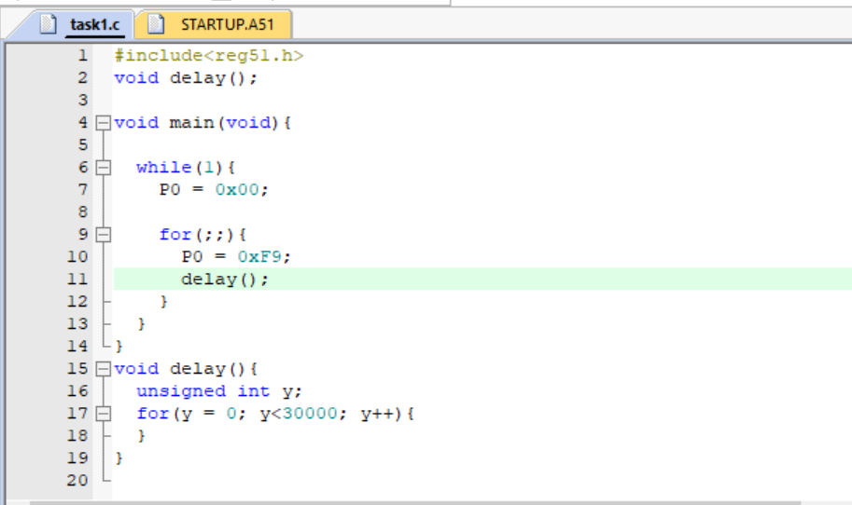

Output:
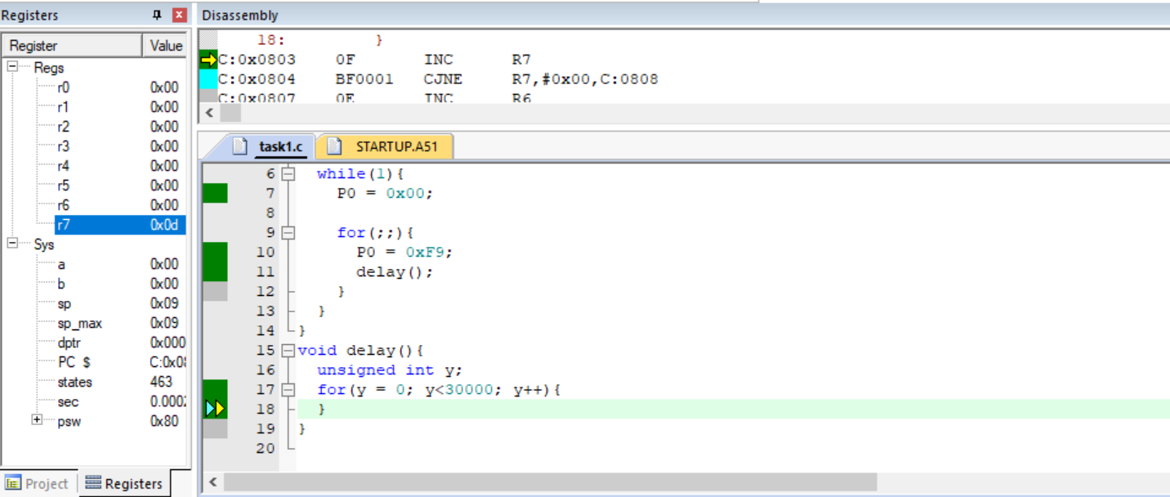

Proteus Simulation:
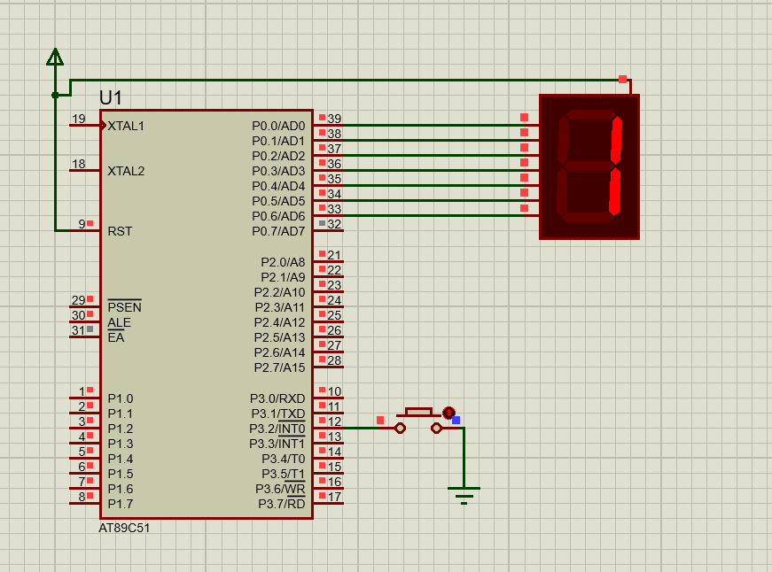

Task 2:
Display different digits on the Seven Segment Display
Code:
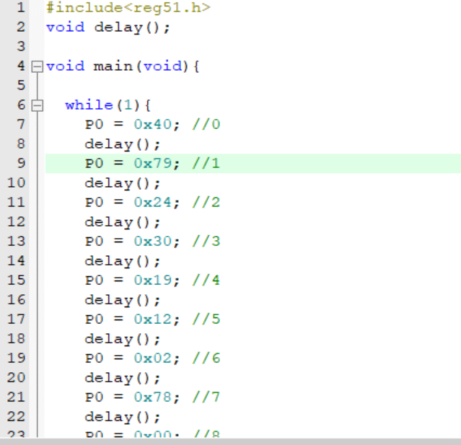

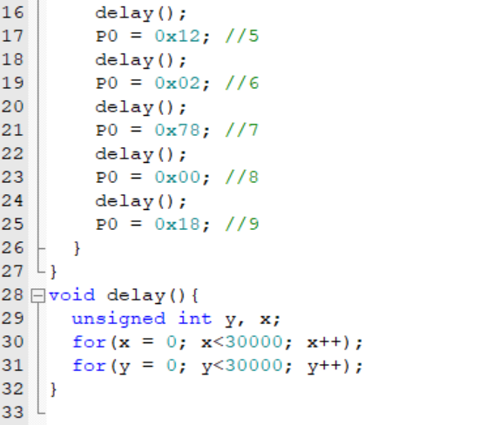

Output:
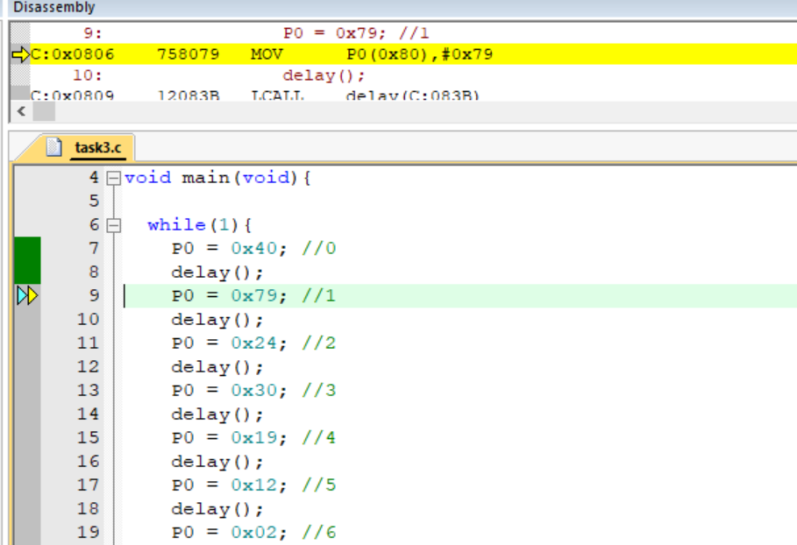
Proteus Simulation:
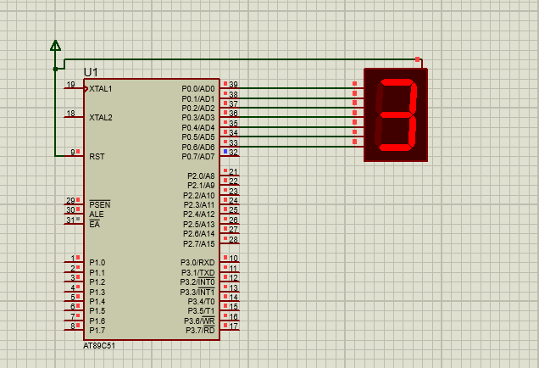
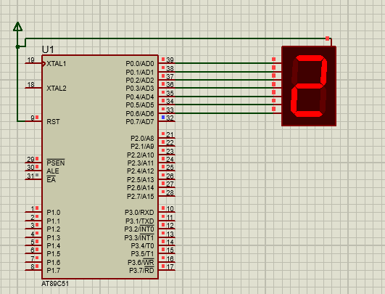

Task 3:
Display digits from 0 to F on Seven Segment Display

Code:
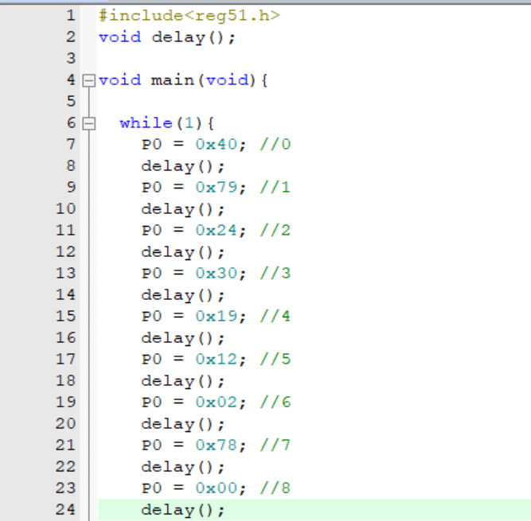
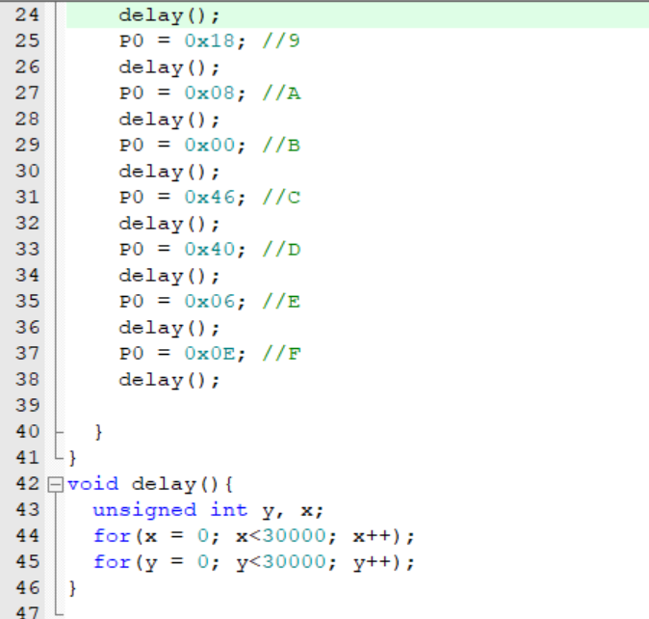

Output:
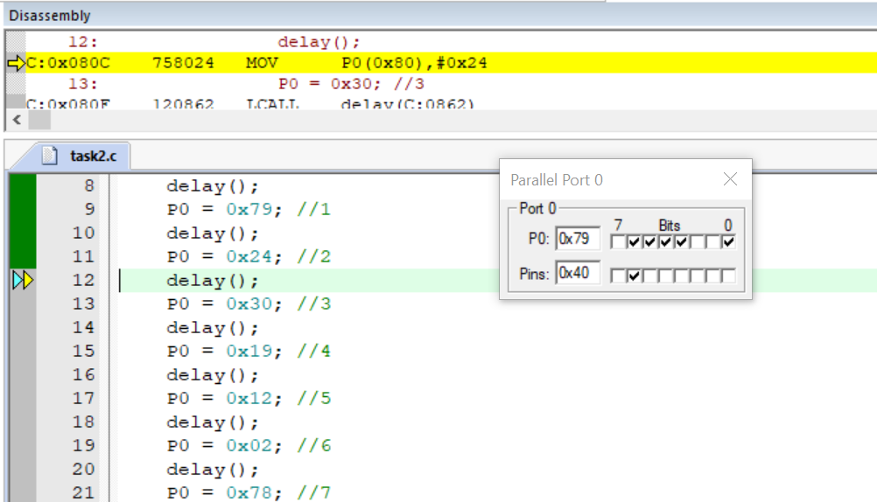

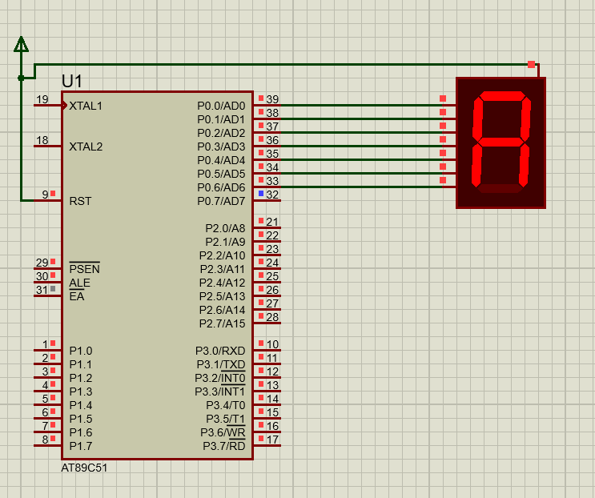
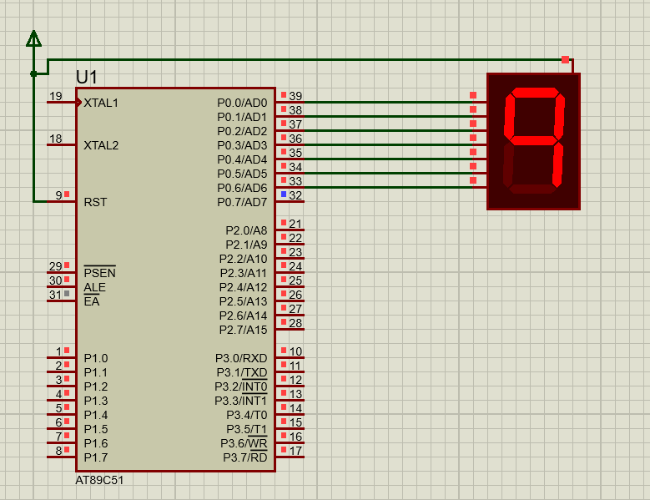
Proteus Simulation:

